GREAT FISH AGILITY | Diagnostic Tool · GreatFishAgility.com/Focus · mark@greatfishagility.com · 804.404.2978

DIAGNOSTIC TOOL
The 60-30-10 Reset Canvas
Map your team’s current state against Hackman’s three performance zones. Be structurally honest — use names and numbers, not adjectives. Bring the completed canvas to a leadership conversation within 48 hours.
HOW TO USE: | Step 1: Describe Current State using specific names, numbers, and allocation percentages. Step 2: Name the Structural Gap — what design decision created this, and who made it? Step 3: Write ONE change (move a line on the org chart or change an allocation %). Step 4: Bring to your next leadership conversation.

 | Current State  What is actually happening right now? | Structural Gap  What design decision created this state? | One Change  Move a line. Change a %. Fix the architecture.
60%  TEAM DESIGN  Membership · Stability Boundaries · Purpose | ▸ Is team membership stable sprint to sprint?  Same people, no rotating cast  ▸ How many projects is each person split across?  List names & allocation percentages  ▸ Is the PO fully dedicated to this team?  Or shared across multiple products?  Write your response here: | ▸ What design decision created this state?  Who made it? Who has authority to change it?  ▸ Does leadership know what this costs?  Have you calculated the context-switching tax in $?  Write your response here: | ▸ One org chart line to move:  Name the change — who, what %, by when  ▸ What does 100% dedication look like here?  Specific names, percentages, and timeframe  Write your response here:
30%  TEAM LAUNCH  Shared Norms · Vision Goals · Relationships | ▸ Can every member state the Sprint Goal in one sentence?  And explain why it matters to a real customer?  ▸ Were team norms explicitly set at launch?  Working agreements, decision rights, DoD?  ▸ Does the team know WHY their work matters?  Strategic outcome, not feature list  Write your response here: | ▸ Was there a real team launch?  Kickoff with shared goals, norms, and relationships?  ▸ What foundation is missing?  Vision? Trust? Decision clarity? All three?  Write your response here: | ▸ What launch investment is overdue?  Half-day session? Goal alignment? Norm reset?  ▸ Who needs to be in the room?  PO, SM, devs — all of them, together, at the same time  Write your response here:
10%  COACHING  Facilitation · Execution Behavior · Events | ▸ Which team events and meetings are producing real value?  Name the event and the specific outcome  ▸ Where is your coaching energy currently focused?  Events, skills, or structural advocacy?  ▸ Are you working in the 10% or the 60%?  Honest answer — this is the diagnosis, not the report card  Write your response here: | ▸ Is coaching masking a design problem?  Would this team improve if the design changed?  ▸ What event or meeting fix have you tried that failed?  What structural issue was it actually hiding?  Write your response here: | ▸ What coaching practice should you stop?  If the design were fixed, what would be unnecessary?  ▸ Where should you redirect this energy?  Design advocacy, exec conversation, backlog surgery?  Write your response here:

PRIORITY ACTION PLAN  Your single highest-leverage structural fix | My #1 structural fix is:  Name the specific org chart change or allocation shift. Be concrete. | The conversation I need to have:  Who needs to say yes? What data will you bring? What’s the ask? | I will do this by:  Name a date — not “soon.” Specific commitments have 3× follow-through.

WHAT TO DO NEXT  with this canvas | STEP 1  Photograph your completed canvas  Take a photo before you leave the room. The canvas is your evidence base — not your notes. | STEP 2  Lead with the cost of inaction  Don’t open with the fix. Open with the number. “We are paying a 60% context-switching tax — that’s $_____ per year.” | STEP 3  Use the Executive WIP Brief  Download it free at GreatFishAgility.com/Focus. It prepares your complete ask so an executive can say yes or no in one meeting.

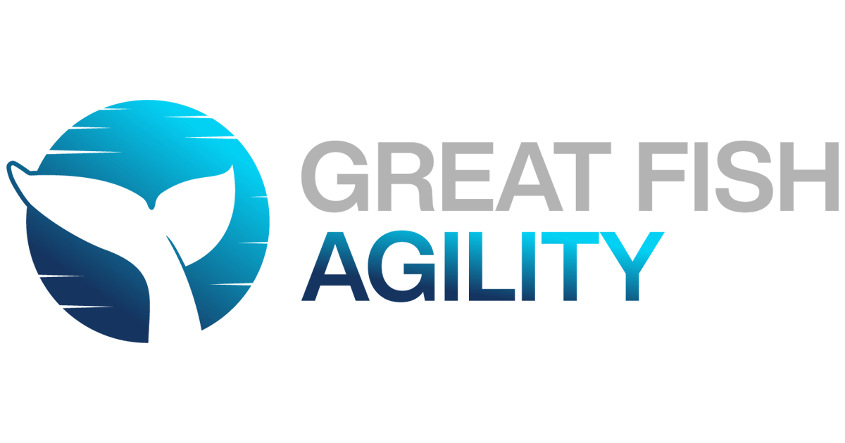

“Performance is a byproduct of environment, not effort.” — Mark Palmer, CST, CTC · GreatFishAgility.com · mark@greatfishagility.com · 804.404.2978

